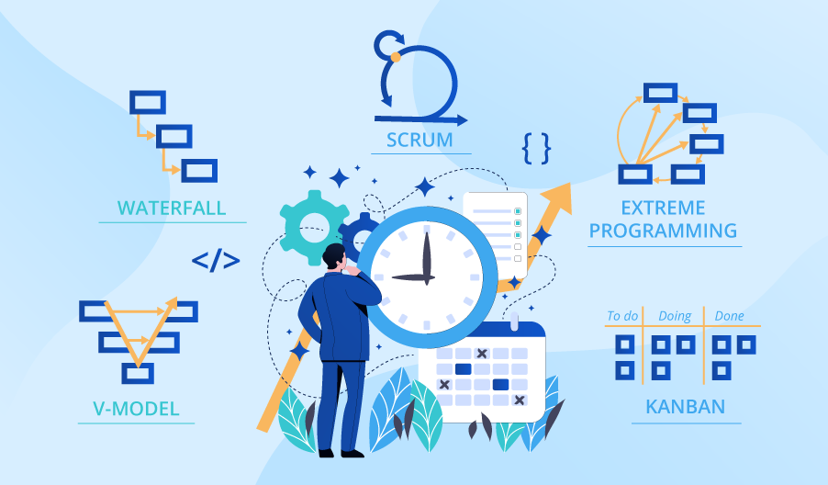

**SE423**

**Software Project Management**

**Assignment**

**Assignment 2. Work Breakdown Structure (WBS) & Scheduling**

For this activity, you will be using a [SmartSheet.com](http://smartsheet.com/) free trial to complete this assignment. Log in via Google for easiest access, and create a new Project. Select the Gantt View for this Assignment. Note that this online application may require saving to properly update.

You need not be a guru with this particular application to complete this assignment, but you may want to familiarize yourself with the basic features to avoid wasting time. Try a few sample entries and see if you can create/differentiate between Phases, Activities, Tasks/Sub-Tasks, and Milestones by means of indentation or manipulation of task duration (e.g. zero duration). All of these elements will need to be included in your final turn-in for full credit.

**Assignment**

1. From as best as you can remember, create a work breakdown structure for your SE423 project.
2. Organize it as a Hybrid WBS; that is identifying deliverables and the tasks required to produce them.
3. Start with a high-level set of releases and then decompose them into more deliverables that are specific.
4. Using the application, create a list of Phases/Activities/Tasks/Milestones at multiple levels as well as a Gantt chart that shows the dependencies between tasks and their corresponding milestones.
5. Assign resources based on a team of four or five, including the names of your current team members.
6. Ignoring the course "target" release dates, go back and play "what-if" with the schedule. For example, could you perform certain tasks in parallel to better make use of your resources?
7. Export a PDF from the Gantt View (File->Export->Export to PDF). Be sure to add additional columns to the export so that Task Name, Duration, Start, Finish, Predecessors, and Assigned-To are included in the PDF.
8. Create a second document entitled "Thoughts and Conclusions" and capture your thoughts/conclusions about the use of this tool and how it may have influenced the process if you had used it for the 423 project. This should be approximately 2 paragraphs in length.

Submit your answers to LMS as PDF file.